|  |  |
| --- | --- |
| To: | City Executive Board |
| Date: | 19th December 2017 |
| Report of: | Head of Financial Services |
| Title of Report: | Treasury Management Performance Report for the six months ending 30th September 2017 |

|  |  |  |
| --- | --- | --- |
| Summary and recommendations | | |
| Purpose of report: | | To report on the performance of the Treasury Management function for the 6 months to 30th September 2017. |
| Key decision: | | No |
| Executive Board Member: | | Councillor Ed Turner, (Deputy Leader) Finance, Asset Management and Public Health |
| Corporate Priority: | | None |
| Policy Framework: | | Efficient and effective Council |
| Recommendation(s):That the City Executive Board resolves to: | | |
| 1. | That the City Executive Board notes the performance of the Treasury Management function for the six months to 30th September 2017 | |
|  |  | |

|  |  |
| --- | --- |
| Appendices | |
| Appendix 1 | The Prudential Code and the Treasury Management Code Proposals |
| Appendix 2 | List of investments as at 30th September 2017 |
| Appendix 3 | Risk Register |

# Introduction and Background

1. In its Code of Practice on Treasury Management, the Chartered Institute of Public Finance and Accountancy (CIPFA) requires that the Council receives an update on its Treasury Management activities at least twice a year. This report provides members with an overview of Treasury Management activity for the first half of the 2017/18 financial year.

# Economic Overview

1. In the first half of the year, growth in the UK economy has weakened; the main reason being the sharp increase in inflation, caused by the devaluation of sterling after the EU referendum increasing the cost of imports. This in turn has caused a reduction in consumer disposable income and so the services sector of the economy, accounting for around 75% of GDP, has seen weak growth as consumers cut back their expenditure. Conversely, the manufacturing sector is seeing strong growth, as a result of increased demand for exports based partly on increase in growth in the EU. However, this sector only accounts for around 11% of GDP so expansion has a much more muted effect on the overall growth figure for the UK economy.

In September 2017 the Monetary Policy Committee (MPC) voted to maintain base rate at 0.25%. However, the majority of members indicated that they would be likely to vote for “some withdrawal of monetary stimulus over the coming months” thereby indicating that a rate increase could be imminent. The MPC met again on 2nd November 2017 and voted unanimously to increase the Base Rate to 0.5%. It is yet to be seen whether this is a one off increase or the start of a slow, but regular, increase in Base Rate. Changes in interest rates have no effect on existing borrowing because the rates are fixed. However, they will affect future borrowing and so the changes in rates will need to be monitored so that borrowing is taken out at the optimum time. Likewise with investment, existing fixed term investments will be unaffected but changes in rates will affect future investment interest rates.

CPI inflation was reported as expecting to peak at just under 3% in 2017, before falling back to near to its target rate of 2% in two years’ time. Inflation in August was 2.9% and so the Bank of England revised its forecast to over 3% at the September MPC meeting.

Up until the MPC’s announcement in September 2017, interest rates continued to fall across all types of investment. However, the very latter part of the half-year has seen some improvement in rates following the expectations of an increase in base rate. Increased interest on fixed term investments has already been experienced in anticipation of the rate rise. In order to maintain a diversified and liquid investment portfolio, the Council continues to invest with a range of counterparties through varying term deposits and notice accounts as well as money market funds and call accounts.

# Investment Performance 2017/18

The performance target for treasury investments is 0.6% above base rate. The target therefore was 0.85% at the start of the financial year. The cumulative average rate of return on investments to 30th September 2017 was 0.91%, which is 0.06% above the performance target of 0.85%. The primary reason for the Council’s return being above target is due to its investments with property funds and it is important to note that without these, the return would fall below target due to longer term investments reaching maturity and being reinvested at lower rates.

The budgeted investment income for 2017/18 is £0.999 million. As at the 30th September 2017, forecast investment income for 2017/18 is £1.323m (an overachievement of £0.324 million). This increase in interest arises due to higher interest rates being achieved than anticipated coupled with higher in-year investment balances than budgeted. Income due to 30th September is £0.725 million.

To date, between £10 million and £25 million has been held in money market funds, with an average balance of £12.9m and earning an annual interest rate in the region of 0.21%. Money market funds are an important investment class due to their liquidity and are used to cover expected and unexpected fluctuations in cash flow.

The Council’s investment balances have gradually increased as the financial year has progressed. Average cash balances in the year to 31st March 2017 were £76.3m and this figure has steadily risen month on month. As at 30th September 2017, the Council’s total investments amounted to just over £94m; this is the usual position for the time of year as cash income exceeds expenditure (due to grant receipts, Council Tax and business rates income etc.); investment balances are expected to decrease towards the end of the financial year when less income is collected.

The Council has a range of investment types (e.g. fixed deposits, certificates of deposit, notice accounts, externally managed property funds, call accounts and money market funds) which are deposited across different counterparties including banks, building societies and Local Authorities. The charts below show the distribution of the Council’s Investment Portfolio by counterparty category and investment type.

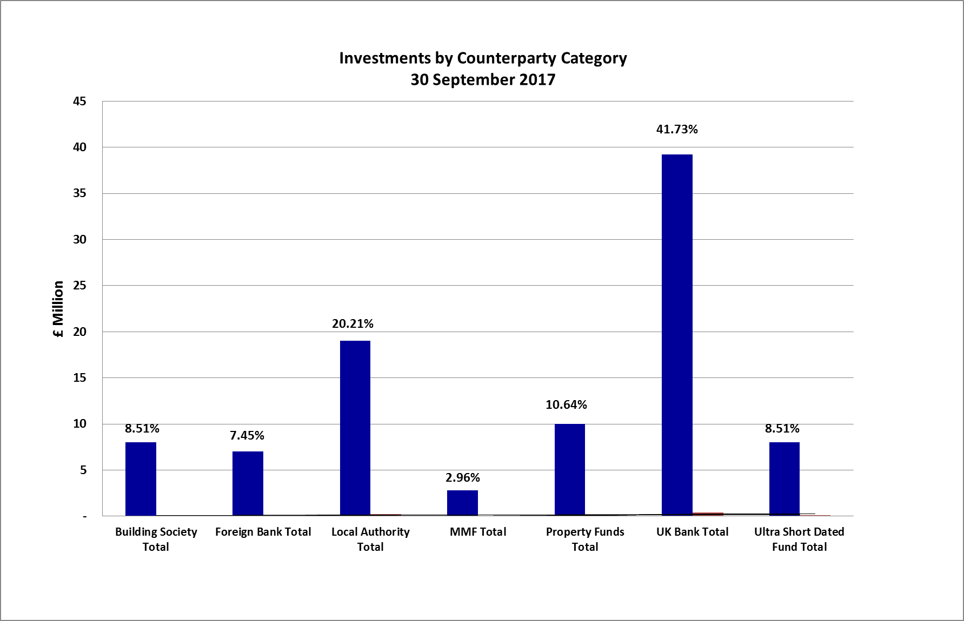

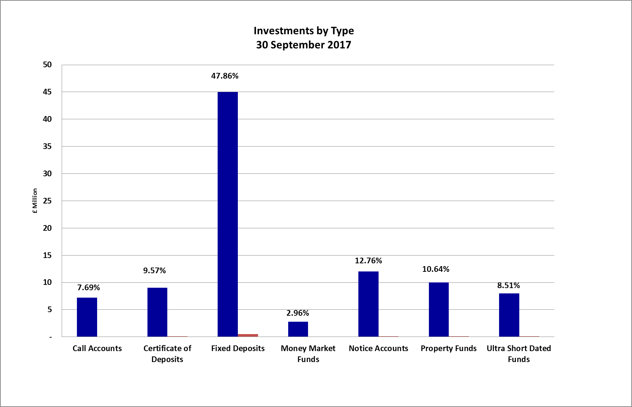

The Council’s Treasury Management Strategy limits non-specified investments (which include property fund and local authority investments of over 364 days) to 25% of the previous year’s average investment portfolio. This limit is reviewed each year when setting the Strategy in order to ensure a balanced and diversified portfolio of investments. £10 million is committed in the CCLA and Lothbury property funds and we are currently looking at utilising residual headroom to invest further in some non-specified investments. It should be noted that the £5 million invested in the National Homelessness Property Fund (Real Lettings) is, following discussions with our external auditors, classified as a service investment undertaken using service delivery powers rather than treasury powers under Section 12 of the Local Government Act 2003.

The graph below compares the Council’s in-house average rate of return for each month to the Bank of England’s Base Rate and the benchmark interest rates:

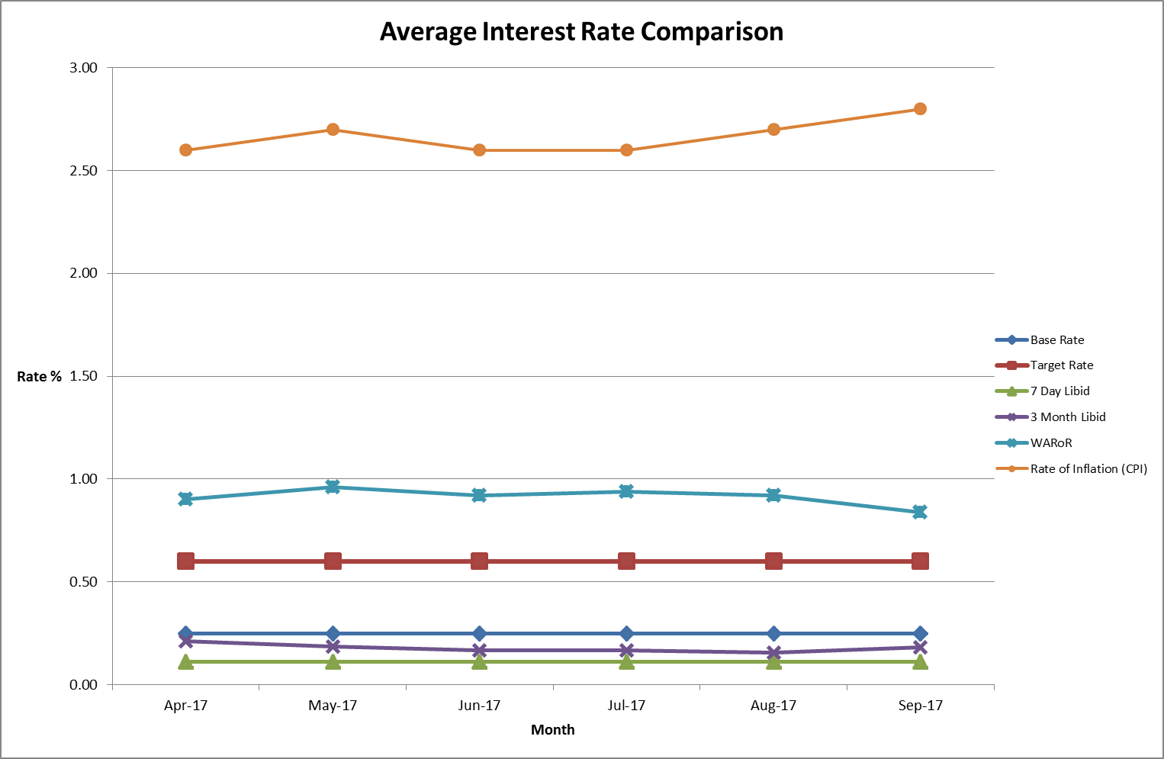

1. The graph shows that the Council has consistently performed above target for the first half of the financial year and it is believed that the rate of return will continue to be above target for the remainder of the year. However, when seen in the context of rising inflation, the rates of return are considerably less favourable due to the continuing low base rate.

# Property Funds

# CCLA Investment Management Limited

CCLA is a specialist investment management firm that acts on behalf of charities, faith organisations, and local authorities. The amount invested in the CCLA property fund was £3m (September 2013). The investment has produced quarterly returns ranging between 5% and 6% and it is expected that the Fund will continue to achieve rates in this region. The impact of this return is illustrated in the average weighted monthly return shown in the interest graph at paragraph 13 above.

Additionally, the value of the Council’s investment with CCLA has appreciated from £3m to £3.75m as at 30th September 2017, equating to growth of 25% to date. However, the values of the individual unit prices have fluctuated over time and the effect of capital appreciation (and depreciation) is illustrated in the graph below. Under current rules any changes to the capital element won’t be realised until the Council sells its property fund units. This is changing in the future and will have an immediate effect on investment income; however, due to the possibility of depreciation, as illustrated below, it is prudent to set aside a significant proportion of the capital to mitigate against any future depreciation of the value.

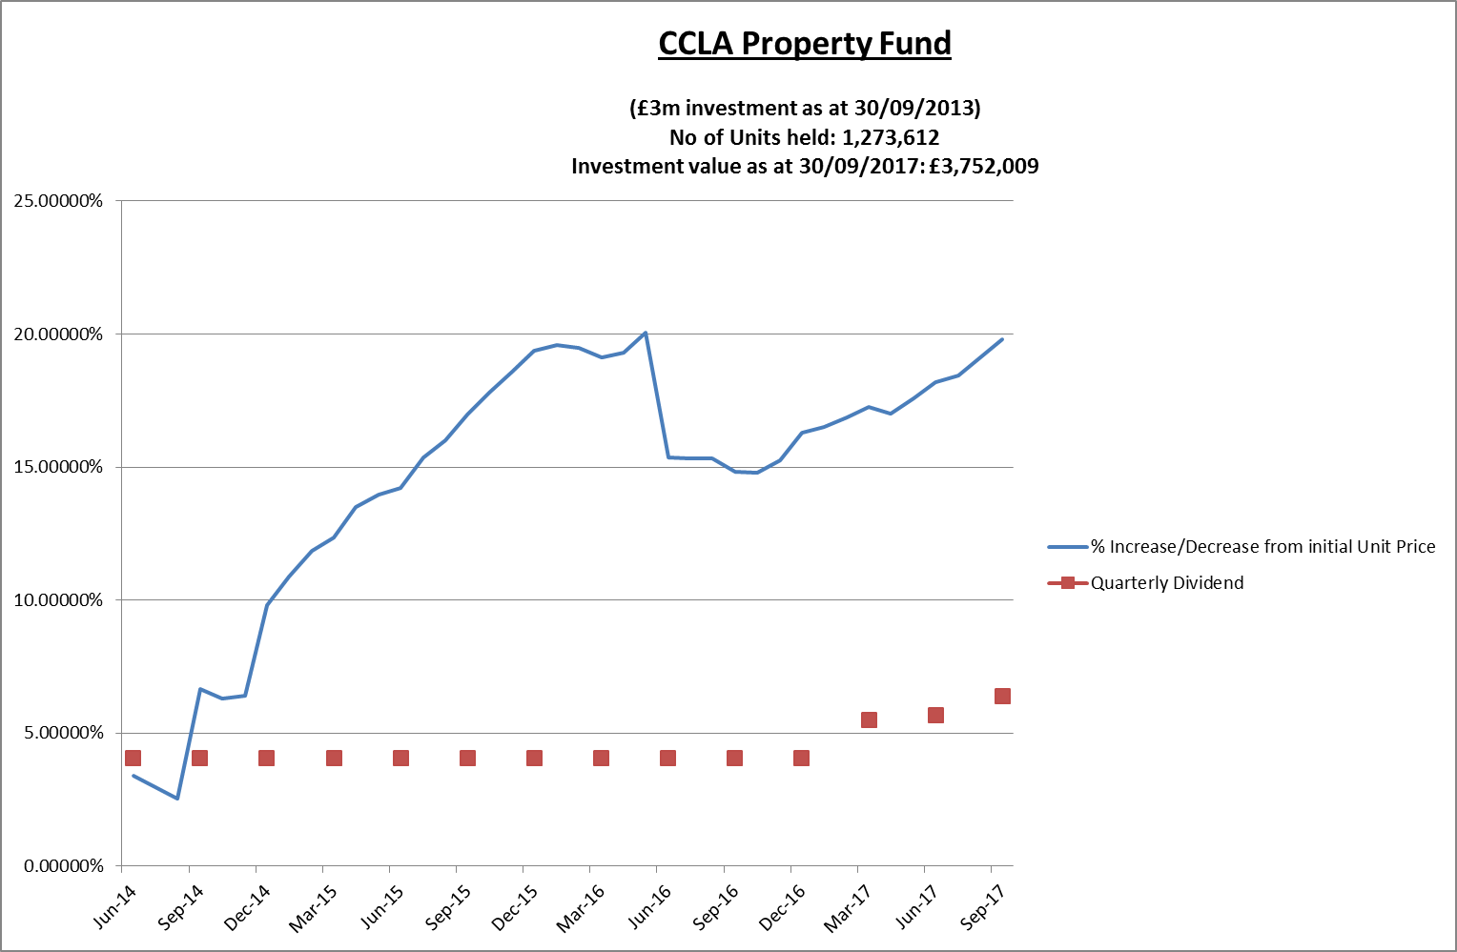

The table below shows the gains and losses made on the fund each quarter this year (plus the figures at 31st March 2017 in order to show the opening position). It also details the quarterly dividends received. The Council holds 1,273,612 units in the Fund and the unit price is re-valued on a monthly basis, reflecting the current value of the investment (but not the interest).



# Lothbury Property Fund

During 2014/15, the Council invested £7m in the Lothbury Property fund and the Fund has produced quarterly returns in the range of 3-4%. Along with CCLA, the impact of this return is illustrated in the average weighted monthly return shown in the interest graph at paragraph 13 above.

The Lothbury fund has also seen capital appreciation over the period with the value currently standing at just over £8m, compared with £7m at inception, equating to overall growth of 15.2% to date. However, as with CCLA, the values of the individual unit prices have fluctuated over time and the effect of capital appreciation (and depreciation) is illustrated in the graph below. The changes to accounting rules will also affect the Lothbury Property Fund as explained in paragraph 15 above.

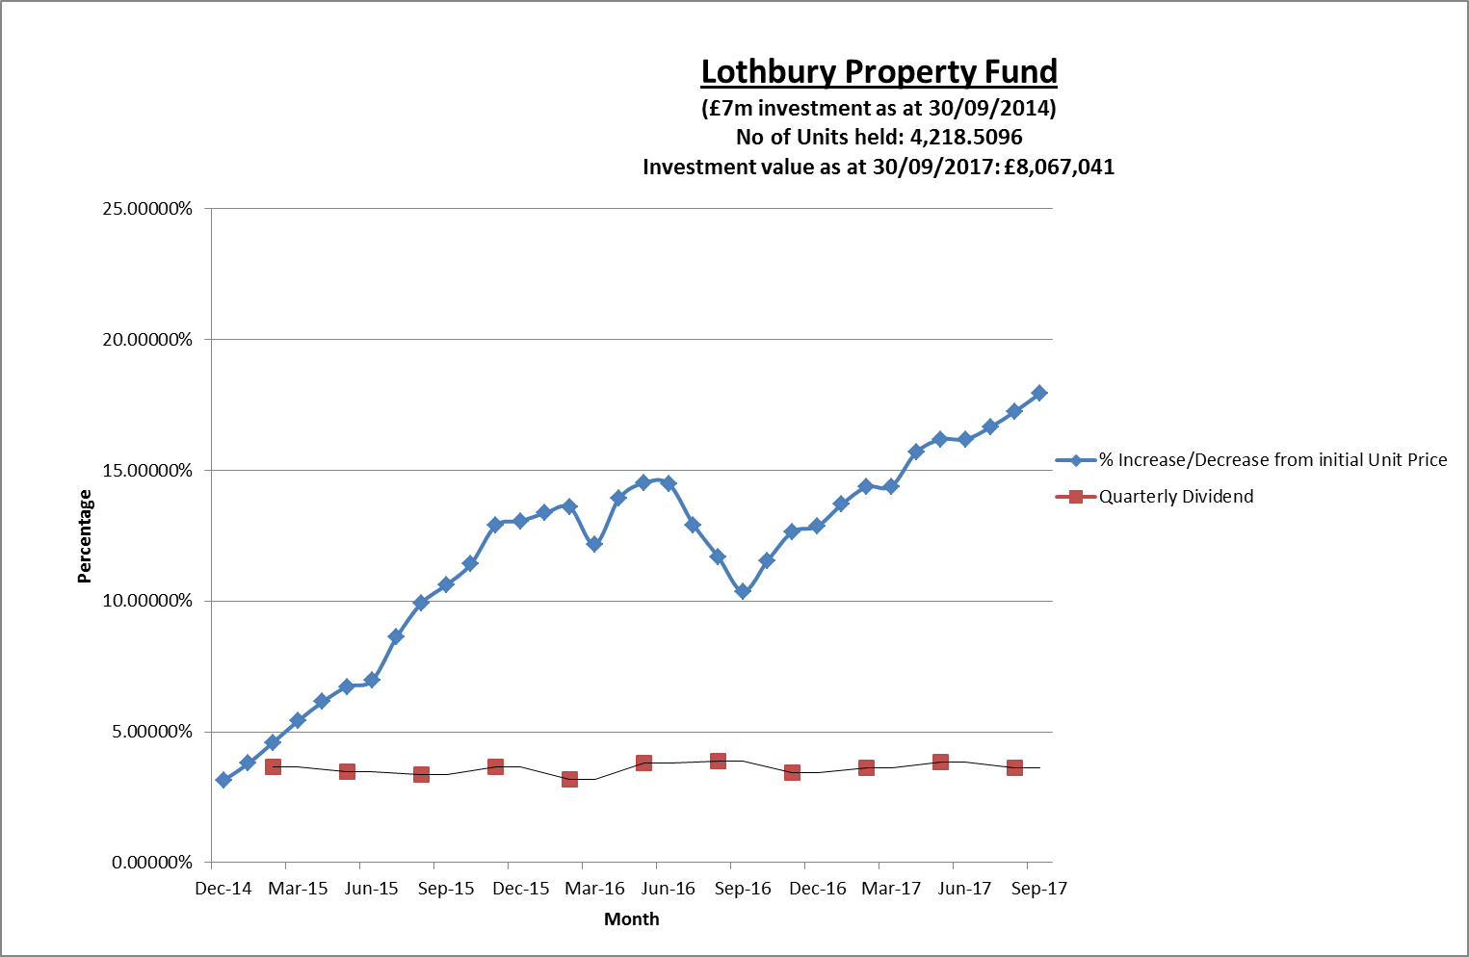

The table below shows the gains and losses made on the Fund each quarter this year (plus the figures at 31st March 2017 in order to show the opening position) as well as the quarterly dividends received. The Council holds 4,219 units in the fund and the unit price is re-valued on a monthly basis, reflecting the current value of the investment (but not the interest).



1. Due to the nature of property investment, the Council is alert to the level of risk involved and there is always a risk of capital losses as well as gains. Therefore, the Council continues to limit its investments in this type of fund to £20m. Following the Brexit referendum in 2016/17, both property funds suffered a temporary loss in value and whilst Lothbury has surpassed its pre Brexit referendum level, CCLA is yet to make a full recovery.

# The Treasury Management Counterparty List

The approved counterparty list provides limits on the amount which can be invested in any one counterparty/counterparty group at any given point. It also confirms the maximum duration permitted per investment. The Council adheres to this listing to ensure it does not breach its Treasury Management Strategy. The list is updated on a weekly basis, or more frequently should changes in the market dictate a more imminent review.

The Council’s approved counterparty list is based upon recommendations from Capita Asset Services although ultimate authorisation of which counterparties are approved rests with the Council’s S151 Officer. In essence, the approved counterparties are determined by credit ratings provided by the three main credit rating agencies and through the monitoring of counterparties’ credit default swap spreads.

# Borrowing

The Council has not taken on any additional debt during the year to date and so the balance of its external borrowing remains at approximately £198.5 million; this figure relates to funds borrowed from the Public Works Loans Board (PWLB) to buy out the Housing Revenue Account (HRA) from the subsidy system and relates wholly to Housing with interest repayment being met by the HRA. The Council does not consider that debt restructuring and/or premature repayment would be practical at this time as due to the differential in interest rates the Council would incur a large premium from the PWLB for doing so. The Council continues to monitor borrowing interest rates and forecasts on a regular basis and will continue to review its position on debt restructuring.

The Council anticipates borrowing in the future to meet its capital expenditure requirements, including loans to the Housing Company, but does not expect any external borrowing will be required in 2017/18. The levels of borrowing currently anticipated are as follows:

|  |  |
| --- | --- |
|  | Anticipated Prudential Borrowing |
|  | £000's |
| 2017/18 | 17,712 |
| 2018/19 | 34,039 |
| 2019/20 | 17,708 |
| 2020/21 | 12,705 |
| 2021/22 | 10,680 |
| 2022/23 | 10,270 |

**The Prudential Code for Capital Finance and the Treasury Management Code**

1. The Chartered Institution of Public Finance and Accountancy (CIPFA) has proposed a number of changes to the Prudential Code for Capital Finance and to the Treasury Management Code, with a view to them being implemented from April 2018.
2. In conjunction with Capita Asset Services, the Council has responded to the proposals and the final Code of Conduct is due to be published by the end of December 2017. The Local Government Association is also expected to be issuing a separate consultation on the proposals. The suggested changes together with the Council’s response are set out in Appendix 1. Key changes proposed that would affect this Council include:

* Removing some current performance indicators - Officers believe there is merit in retaining some of these;
* Extending the maximum investment period for specified investments from 364 to 365 days – this would allow the use of year-long investment periods over a larger proportion of the investment portfolio and is welcomed;
* Including all investments within the remit of the Treasury Management Code which would include service-type investments - this is not the current remit of the Treasury Management function and it is not felt appropriate to regulate these in the same way;
* Specifying the roles of members within Treasury Management reporting which could change the way that Treasury Management is reported and scrutinised by the Council - Officers consider that the current reporting mechanisms and levels of engagement currently in place are appropriate to needs.

# Financial implications

1. All financial implications are contained within the body of this report.

# Legal issues

1. There are no legal implications directly relevant to this report.

# Level of risk

1. There are no risks in connection with the report’s recommendations. Risk assessment and management is a key part of Treasury Management activity especially in the selection of counterparties when considering investment opportunities. The Council uses external advisors and counterparty credit ratings issued by the rating agencies to assist in this process.

# Equalities impact

1. There are no equalities impacts arising directly from this report.

|  |  |
| --- | --- |
| **Report author** | Bill Lewis |
| Job title | Financial Accounting Manager |
| Service area or department | Financial Services |
| Telephone | 01865 252607 |
| e-mail | blewis@oxford.gov.uk |

|  |
| --- |
| Background Papers: None |